Friends Of The Emm Brook

“protecting and enhancing the Emm Brook and its floodplain for wildlife and people”

Newsletter No 8 www.emmbrook.org.uk April 2007

The Emm Brook breeding bird survey for 2007 is about to begin. This is the 3rd year of what is planned to be a long term survey, to give a view overtime of the regular birds that use the Emm Brook as breeding habitat. Several teams of volunteers make 2 visits each year in Late April/ early May and Late May/early June, along their assigned sections of the Brook and record the nesting birds seen and heard. The Riverside Walk team recorded 25 species last year and were lucky enough to see a Kingfisher. The Kingfisher is a spectacular bird, but the other birds which may be less flamboyant , are important indicators of habitat, such as the Wren with its perky little tail, and the Dunnock with its grey head
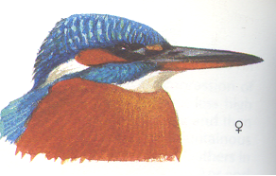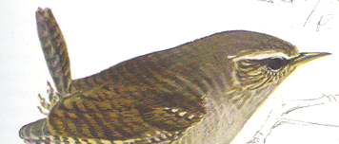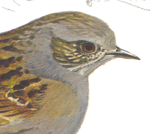
kingfisher wren dunnock

Friends of the Emm Brook
AGM
May 22nd 7.30pm
The 2007 annual general meeting will be held at Woosehill Community Centre
Every one welcome. Nominations for the committee especially welcome

Himalayan Balsam
For the 3rd year we shall try to reduce the amount of Himalayan Balsam along the banks of the Emm Brook where it flows beside Emmbrook School. Last year it seemed that we were being quite successful. If we can reduce it, that will give our native vegetation more chance to flourish, providing food for the invertebrates that feed our birds. We do understand how attractive the plant looks But it is very invasive, is non native and smothers other plant species. If any members wish to join these work parties they will be at 11.00am on Sundays 10 & 24 June and 8 July. Please phone Sue Farrington (978 2371) or Jean Vaughan (979 0538) for details the previous week.

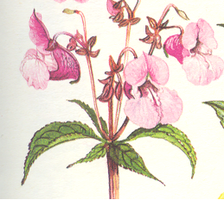

Riverside Walk

This year Wokingham Borough Council has agreed to trial some changes in the grass mowing regime
at Riverside Walk, the part of the Emm Brook which flows from Meadow Rd near to Morrisons in
Woosehill. By mowing closer to the stream for some short stretches the view of the Brook should be
improved for those walking through the park. One area of grass is being allowed to grow longer to
encourage more wild flowers to grow and seed. We would welcome any constructive comments
you feel able to make (to the chairman please). Perhaps in the future some wildflower seeds or plants
could be added as has been done at Holt Copse, to enhance the area.
If you have any other ideas/comments do get in touch, or even join our committee!
We would welcome you.

Kick Sampling De-Culverting
A funny name for a simple process which Good news about the new developments in
helps biologists to assess the numbers and Molly Millars Lane. It looks as if the Brook will
types of invertebrates present in rivers and be de-culverted in 2 places where there are now
streams. Culverts, which can only be a bonus for the
The first of this years sampling sessions will wildlife in and around the Brook.
take place on Sunday 13th May at 2.30pm.
Please contact Mike Saynor on 978 1804 for Watch this space
details.

Nest Boxes
Last years boxes have been cleaned and put back , and a working party in March added another 20 boxes
suitable for a variety of birds. Bird species have different requirements for their nests, ie big holes,
small holes, height, privacy, ability to see predators etc, and some are quite picky about which tree they
will choose. Last year’s boxes were all occupied and we hope that the new ones will be just as popular.
NB The new boxes are made of a durable material known as woodcrete.

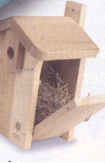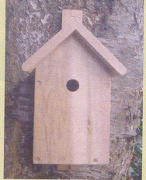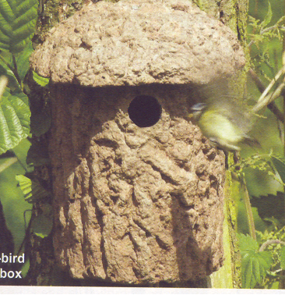

Veteran Trees

Don’t forget to look at the Veteran Trees that occur along the Emm Brook. If it is more than
3 metres in diameter it is a veteran.

Copy for the next newsletter should be sent to Marie_Fry@msn.com tel 978 9813 or by snail
mail to 25A Station Rd Wokingham RG40 2AD

